**Đề luyện 2_đáp án**

**#1 When test cases are designed early in the lifecycle, verifying the test basis via the test design, which common test objective is being achieved?**

a. Gaining confidence

b. Finding defects

**c. Preventing defects**

d. Providing information for decision making

**#2 When following the fundamental test process, when should the test control activity take place?**

a. During the planning activities

b. During the implementation and execution activities

c. During the monitoring activities

**d. During all the activities**

**#3 Designing and prioritizing high level test cases occurs during which activity in the fundamental test process?**

a. Test planning

**b. Test analysis and design**

c. Test implementation and execution

d. Evaluating exit criteria

**#4 Which of the following could be a reason for a failure**

1) Testing fault

2) Software fault

3) Design fault

4) Environment Fault

5) Documentation Fault

a. 2 is a valid reason; 1,3,4 & 5 are not

b. 1,2,3,4 are valid reasons; 5 is not

c. 1,2,3 are valid reasons; 4 & 5 are not

**d. All of them are valid reasons for failure**

**#5 Which of the following is a correct statement?**

**a. A developer makes a mistake which causes a defect that may be seen as a failure during dynamic testing**

b. A developer makes an error which results in a failure that may be seen as a fault when the software is executed

c. A developer has a failure which results in a defect that may be seen as a mistake during dynamic testing

d. A developer makes a mistake which causes a bug that may be seen as a defect when the software is executed

**#6 Which of the following is an example of debugging?**

a. A tester finds a defect and reports it

b. A tester retests a fix from the developer and finds a regression

**c. A developer finds and fixes a defect**

d. A developer performs unit testing

**#7 Which of the following is a true statement about exhaustive testing?**

a. It is a form of stress testing

**b. It is not feasible except in the case of trivial software**

c. It is commonly done with test automation

d. It is normally the responsibility of the developer during unit testing

**#8 When should the testers start reviewing project documents?**

a. When they have been baselined and approved

b. After the first revision

**c. As soon as a draft is available**

d. When the developers have started coding

**#9 Which of the following is most correct regarding when functional/non-functional tests may be executed?**

a. Unit and integration

b. Integration and system

c. System and acceptance

**d. All levels**

**#10 Which of the following is the correct list of the triggers for maintenance testing?**

**a. A component in production is modified, migrated or retired**

b. A fix has been received for a product that is in development

c. A regression has been discovered in a set of fixes just received from the developer

d. A new requirement has been received for the software that is currently under test that may result in an architectural change

**#11 In a V-model lifecycle, what should testers be doing when the design documents are available?**

a. Preparing unit test code

**b. Preparing functional and non-functional test cases**

c. Reviewing the high-level requirements documents

d. Preparing system acceptance tests

**#12 Usability testing is an example of which type of testing?**

a. Functional

**b. Non-functional**

c. Structural

d. Change-related

**#13 In a formal review, which role is normally responsible for documenting all the open issues?**

a. The moderator

b. The author

**c. The scribe**

d. The manager

**#14 Which of the following is a type of issue that is best found in static analysis?**

a. An inaccurate formula

b. A memory leak

**c. A piece of dead code**

d. A problem with the code not matching the requirements

**#15 Which testing technique would be most effective in determining and improving the maintainability of the code (assuming developers fix what is found)?**

a. Peer reviews

**b. Static analysis**

c. Dynamic testing

d. Unit testing

**#16 Given the following state transition diagram:**

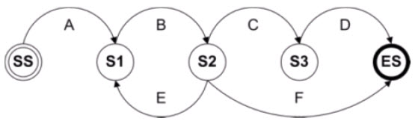

**Which of the test cases below will cover the following series of state transitions?**

**SS – S1 – S2 – S1 – S2 – ES**

**a. A, B, E, B, F**

b. A, B, C, D

c. A, B, E, B, C, D  
d. A, B, F

**#17 If test cases are derived from looking at the code, what type of test design technique is being used?**

a. Black-box

**b. White-box**

c. Specification-based

d. Behavior-based

**#18 Which document specifies the inputs and outputs for a test?**

a. Test design specification

**b. Test case specification**

c. Test procedure specification

d. Test plan

**#19 How does a test condition relate to a test case?**

a. A test condition defines the test case

**b. A test case tests a test condition**

c. A test condition is the output from a test case

d. A test case creates test conditions

**#20 Which of the following is a good reason to use experience-based testing?**

**a. You can find defects that might be missed by more formal techniques**

b. You can test for defects that only experienced users would encounter

c. You can target the developer’s efforts to the areas that users will be more likely to use

d. It is supported by strong tools and can be automated

**#21 If you are using error guessing to target your testing, which type of testing are you doing?**

a. Specification-based

b. Structure-based

**c. Experience-based**

d. Reference-based

**#22 If you are testing a module of code, how do you determine the level of decision coverage you have achieved?**

a. By taking the number of decisions you have tested and dividing that by the total number of executable statements in the module

b. By taking the number of decisions you have tested and dividing that by the total number of decisions in the module

c. By taking the number of decisions you have tested and dividing that by the total lines of code in the module

**d. By taking the number of decision outcomes you have tested and dividing that by the total number of decision outcomes in the module**

**#23 You have been tasked with organizing a set of test cases into a test procedure that will indicate the order in which the test cases will be run.**

The order of execution is important because you are trying to test end-to-end transactions in this e-commerce book sales application, but you must also consider the priority of the test cases as some are more critical than others.

Given the test cases in this table, what would be the best order for execution to achieve both goals? (Note: 1 is the highest risk)

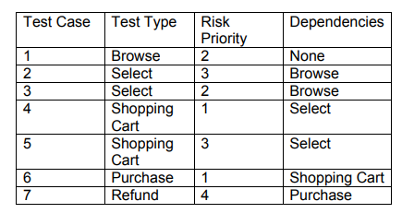

a. 4, 6, 1, 3, 2, 5, 7

b. 1, 2, 5, 6, 7, 1, 3, 4, 6, 7

**c. 1, 3, 4, 6, 1, 2, 5, 6, 7**

d. 1, 3, 2, 4, 5, 6, 7

**#24** Consider the following state table:

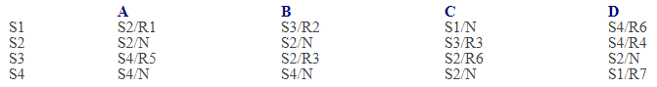

Which of the following would result in a change of state to S2 with an action of R6?

a. From state S1, input A

b. From state S2, input B

**c. From state S3, input C**

d. From state S4, input D

**#25 You are testing a machine that scores exam papers and assigns grades.**

Based on the score achieved the grades are as follows:

1-49 = F, 50-59 = D, 60-69 = D, 70-79 = C, 80-89 = B, 90-100=A

If you apply equivalence partitioning, how many test cases will you need to achieve minimum test coverage?

a. 6

**b. 8**

c. 10

d. 12

**#26 You are testing a machine that scores exam papers and assigns grades.**

Based on the score achieved the grades are as follows:

1-49 = F, 50-59 = D, 60-69 = D, 70-79 = C, 80-89 = B, 90-100=A

If you apply boundary value analysis, how many test cases will you need to achieve minimum test coverage?

a. 8

b. 10

c. 12

**d. 14**

**#27 Consider the following high level program design and assume you can provide the values for today, A, B and C:**

Start;

Do until B = C

If today = Monday

set A = 1

elseif today = Wednesday

Set A = 2

Set B = C

Endif;

If B < C

B = B + 1

Endif;

Endloop;

End;

Which of the following sets of values will achieve 100% decision coverage with the least number of test cases (the order of the values is today, A, B, C)?

**a. Monday, 1, 3, 3; Monday 3, 2, 4; Wednesday, 1, 2, 3; Tuesday, 5, 4, 3**

b. Monday, 1, 2, 4; Wednesday 1, 2, 4

c. Monday, 5, 1, 1; Tuesday, 5, 1, 2; Wednesday, 5, 1, 2

d. Monday, 5, 3, 2; Monday, 5, 1, 1; Monday 5, 2, 3; Tuesday, 4, 4, 3; Wednesday, 1, 2, 3

**#28 Given the following program fragment:**

if day = Monday

then statement a

else

statement b

end if

if day = Tuesday

then statement c

end if

What is the minimum number of test cases needed to achieve 100% statement coverage?

a. 1

**b. 2**

c. 3

d. 4

**#29 Which of the following is a task that a test leader would be expected to do?**

**a. Write a test strategy**

b. Set up a test environment

c. Prepare test data

d. Automate tests

**#30 A metric that tracks the number of test cases executed is gathered during which activity in the test process?**

a. Planning

b. Implementation

**c. Execution**

d. Reporting

**#31 Which of the following is a true statement about test planning?**

a. It should be done at the beginning of the project

**b. It should be a continuous activity throughout the project**

c. It should be started during design and finished before execution

d. It should be used as input for the test strategy

**#32 If you are applying risk-based testing, which type of test approach are you using?**

**a. Analytical**

b. Methodical

c. Regulatory

d. Model-based

**#33 What is covered in the variances section of the Test Summary Report?**

a. The variances between the weekly status reports and the final summary report

b. The variances between the defects found and the defects fixed

**c. The variances between what was planned for testing and what was actually tested**

d. The variances between the test cases executed and the total number of test cases

**#34 Which of the following is a project risk?**

a. A module that performs incorrect calculations due to a defect in a formula

b. A failed performance test

c. An issue with the interface between the system under test and a peripheral device

**d. A problem with the development manager which is resulting in his rejecting all defect reports**

**#35 You have been given the following set of test cases to run**.

You have been instructed to run them in order by risk and to accomplish the testing as quickly as possible to provide feedback to the developers as soon as possible. Given this information, what is the best order in which to run these tests?

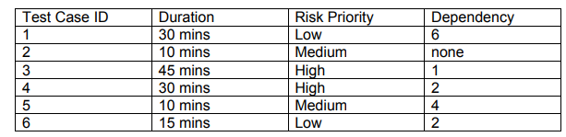

**a. 2, 4, 5, 6, 1, 3**

b. 4, 3, 2, 5, 6, 1

c. 2, 5, 6, 4, 1, 3

d. 6, 1, 3, 2, 4, 5

**36# The Following table shows 6 test procedures (P to U) that must now be entered into a test execution schedule**

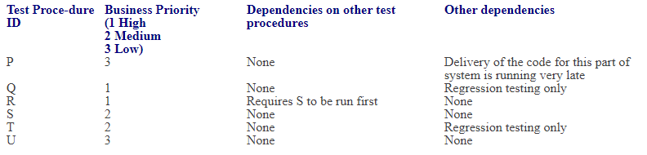

Business severity is regarded as the most important element in determining the sequence of the test procedures, but other dependencies must also be taken into consideration. Regression testing can only be run once all other tests have completed.

 Which of the following represents the MOST effective sequence for the test execution schedule (where the first entry in the sequence is the first procedure to be run, the second entry is the second to be run and so on)?

a. R, Q, S, T, U, P

b. S, R, P, U, Q, T

c. Q, R, S, T, P, U

**d. S, R, U, P, Q, T**

**#37 Which of the following is a true statement about test automation scripts that are captured using a capture/replay tool?**

a. The scripts are easy to maintain

b. The scripts are data-driven

**c. The scripts may be unstable**

d. The scripts are created by experienced automators

**38# Given the following decision table:**

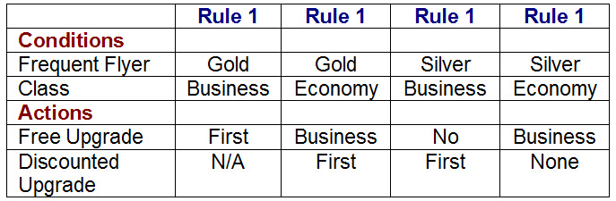

What is the expected result for each of the following test cases?

P. Gold frequent flyer, travelling in Economy class.

Q. Silver frequent flyer, travelling in Business class.

**a. P. Offer free upgrade to Business and discounted upgrade to First. Q. Offer discounted upgrade to First**

b. P. Offer free upgrade to Business but cannot upgrade to First. Q. Offer discounted upgrade to First

c. P. Offer free upgrade to First. Q. Cannot upgrade to First

d. P. Offer discounted upgrade to First. Q. Offer free upgrade to First

**39#** An automated air-conditioner is programmed to turn its heating unit on when the temperature falls below 17 Deg. C and to turn its refrigeration unit on when the temperature exceeds 26 Deg. C. The air-conditioner is designed to operate at temperatures between -10 Deg. C and +40 Deg. C. Given the above specification, which of the following sets of values shows that the equivalence partition test design technique has been used correctly?

**a. -11 Deg. C, -1 Deg. C, 18 Deg. C, 27 Deg. C, 51 Deg. C**

b. -11 Deg. C, -1 Deg. C, 12 Deg. C, 18 Deg. C, 27 Deg. C, 51 Deg. C

c. -11 Deg. C, 18 Deg. C, 51 Deg. C

d. -1 Deg. C, 12 Deg. C, 18 Deg. C, 27 Deg. C

**#40 If a test tool is causing a probe effect, what does this mean?**

**a. The outcome of the test may be influenced by the use of the tool**

b. The tool is used to continuously probe the software for defects

c. The tool is used primarily to assist with exploratory testing

d. The tester will require special training to be able to effectively use the tool